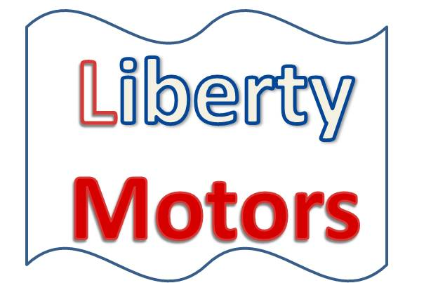

20 North Broad Street

St. Louis, MO 63146

(314) 555-0030

September 1, 2016

Dear :

Liberty Motors appreciates your business and continued support. We will be offering our current customers some very enticing promotions. Please visit our showroom to register for some wonderful prizes.

|  |  |
| --- | --- |
| **Month** | **Promotion** |
| September – October | Detailing Packages |
| November – December | Tires for Life |
| January – February | Dinner for Two |
| March – April | Caribbean Cruise |
| May – June | $500 in Gasoline |
| July – August | Branson Show Ticket Package |

Sincerely,

Firstname Lastname